***AIM : DESIGN AN AUTOMATIC NIGHT LAMP***

APPARATUS REQUIRED :-

Arduino, LDR, LED, Resistor (10K, 220), Wires, Breadboard.

CIRCUIT DIAGRAM :-

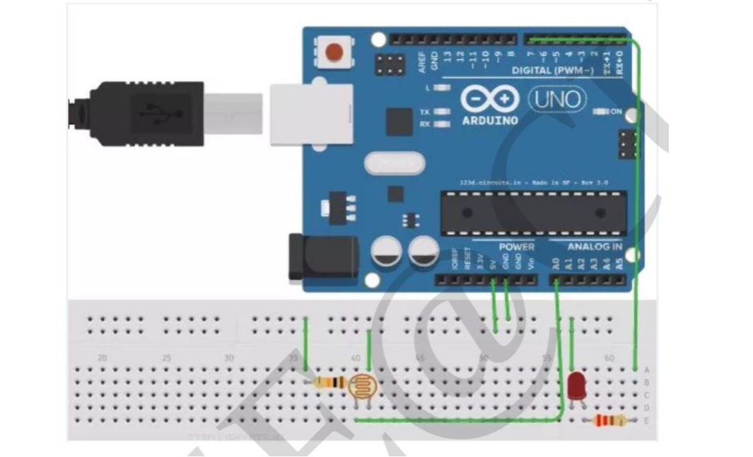

THEORY :-

LED are particular type of diode that converts electrical energy into light. LED stands for “Light Emmiting Diode”. LEDs are tiny bulbs. However, LEDs requires a lot less power. LEDs have two terminals. The positive side of the LED is called the “anode” and is marked by having a longer “lead” or “leg”. The other negative side of the LED is called the “Cathode”. Currents always flows from the anode to the cathode direction.

PROGRAM :-

Const int lamp = 7

Void setup()

{

Serial.begin(9600);

pinMode(lamp, OUTPUT);

}

Void loop()

{

Int c = analogRead(A0);

Delay(500);

If (c<300);

{

DigitalWrite(lamp, HIGH);

Delay(1000);

}

else

{

digitalWrite(lamp, LOW);

delay(1000);

}

}

LEARNING AND OBSERVATIONS :-

1. When the dark is appear then LED glows automatically and when the brightness is appear then LED turn off automatically. 2. This is very helpful to us. Maily this is used in the bedroom.

PRECAUTIONS :-

1. Always ensure the positive terminal of the LEDs is connected to the output pin of the Arduino Uno. 2. Before uploading the code to the Arduino Uno (micro controller). Check the port and board under the tools menu. 3. Always ensure that the connections are tightly. There should not be any loose connections between the port and the Arduino and Arduino and the breadboard. 4. Always check the LEDs is working or not before connecting to the circuit with the help of multimeter.

RESULTS :-

Automatic night lamp functioning was verified was verified after uploading the program.